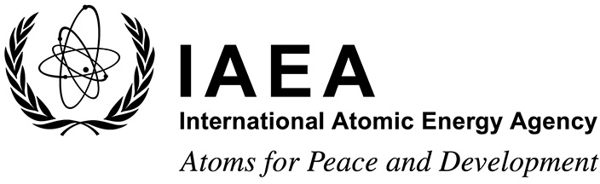

# Participation Form

### Form A

**EVT2205141**

### Technical Meeting on Decision Making for Environmental Remediation

#### IAEA Headquarters, Vienna, Austria and virtual participation via Cisco Webex 4 to 8 September 2023

To be completed by the participant and sent to the competent national authority (e.g. Ministry of Foreign Affairs, Permanent Mission to the IAEA, or National Atomic Energy Authority) of his/her country for subsequent transmission to the International Atomic Energy Agency (IAEA) either by email to: [Official.Mail@iaea.org](mailto:official.mail@iaea.org) or by fax to:

+43 1 26007 (no hard copies needed). Please also send a copy by email to the Scientific Secretary, Mr Horst Richard

S. Monken Fernandes, Division of Nuclear Fuel Cycle and Waste Technology, Department of Nuclear Energy (Email: H.Monken-Fernandes@iaea.org) and to the Administrative Secretary, Mr Jovan Catovic, (Email: J.Catovic@iaea.org).

Participants who are members of an invited organization can submit this form to their organization for subsequent transmission to the IAEA.

**Deadline for receipt by IAEA through official channels: 31 May 2023**

|  |  |  |  |
| --- | --- | --- | --- |
| Family name(s): (same as in passport) | | First name(s): (same as in passport) | Mr/Ms |
| Institution: | | | |
| Full address: | | | |
| Tel. (Fax): | | | |
| Email: | | | |
| Nationality: | Representing following Member State/non-Member State/entity or invited organization: | | |
| If/as applicable:  Do you intend to submit a paper? Yes No Would you prefer to present your paper as a poster? Yes No Title:  I plan to attend virtually: Yes No | | | |

Participants are hereby informed that the personal data they submit will be processed in line with the [Agency’s Personal Data and Privacy Policy](https://www.iaea.org/about/privacy-policy) and is collected solely for the purpose(s) of reviewing and assessing the application and to complete logistical arrangements where required. The IAEA may also use the contact details of Applicants to inform them of the IAEA’s scientific and technical publications, or the latest employment opportunities and current open vacancies at the IAEA. These secondary purposes are consistent with the IAEA’s mandate.

### Form C

#### EVT2205141

**International Atomic Energy Agency**

# Grant Application Form

### Technical Meeting on Decision Making for Environmental Remediation

#### IAEA Headquarters, Vienna, Austria and virtual participation via Cisco Webex 4 to 8 September 2023

To be completed by the participant and sent to the competent national authority (e.g. Ministry of Foreign Affairs, Permanent Mission to the IAEA, or National Atomic Energy Authority) of his/her country for subsequent transmission to the International Atomic Energy Agency (IAEA) either by email to: [Official.Mail@iaea.org](mailto:official.mail@iaea.org) or by fax to: +43 1 26007 (no hard copies needed). Please also send a copy by email to the Scientific Secretary, Mr Horst Richard S. Monken Fernandes, Division of Nuclear Fuel Cycle and Waste Technology, Department of Nuclear Energy (Email: H.Monken-Fernandes@iaea.org) and to the Administrative Secretary, Mr Jovan Catovic, (Email: J.Catovic@iaea.org).

**Deadline for receipt by IAEA through official channels: 31 May 2023**

|  |  |  |  |
| --- | --- | --- | --- |
| Family name(s): (same as in passport) | First name(s): (same as in passport) | | Mr/Ms: |
| Mailing address: | | Tel.: | |
| Fax: | |
| Email: | |
| Date of birth (yy/mm/dd): | | Nationality: | |
| I plan to attend virtually: | | Yes No | |

##### Education (post-secondary):

|  |  |  |  |  |
| --- | --- | --- | --- | --- |
| Name and place of institution | Field of study | Diploma or Degree | Years attended from to | |
|  |  |  |  |  |
|  |  |  |  |  |
|  |  |  |  |  |
|  |  |  |  |  |

1. **Recent employment record (starting with your present post):**

|  |  |  |  |  |
| --- | --- | --- | --- | --- |
| Name and place of employer/ organization | Title of your position | Type of work | Years worked from to | |
|  |  |  |  |  |
|  |  |  |  |  |
|  |  |  |  |  |

Page 1

Page 2

##### Description of work performed over the last three years:

1. **Institute’s/Member State’s programme in field of event:**

##### Date: Signature of applicant:

**Date: Name, signature and stamp of Ministry of Foreign Affairs, Permanent Mission to the IAEA or National Atomic Energy Authority**